CONSTRUCTION SEQUENCE
SOUTH SIDE
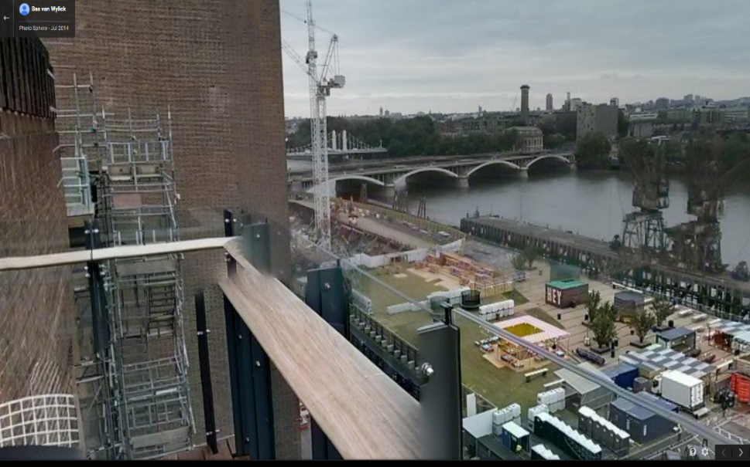

As is visible in this image there's is a large amount of space to the left of the main pier, plenty enough to construct a large abutment.

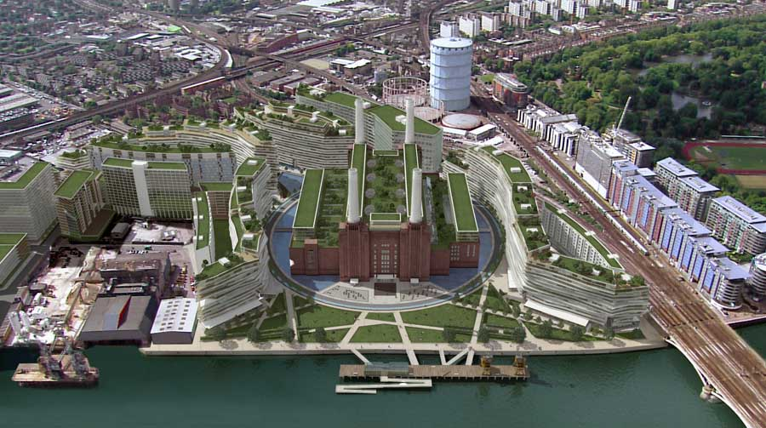
This is the planned redevelopment that is already underway. Clearly these building will make accessing the site difficult.
However a route through the buildings is still possible as shown by the red line.

But due to the narrow roads it will be difficult to preassemble the pieces and then carry them in, meaning that the majority of the construction and assembling will have to be carried out on the site.

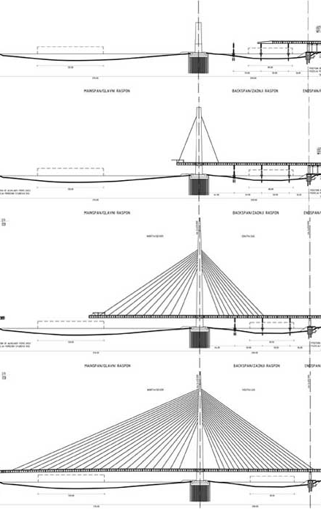
Here the pylon and its abutment are being constructed. The south side support cable foundation is also being built.

In this stage, the first cable has been put in place, along with the basic walkway which it supports.

Here more cables are being added and the length of the pylon and walkway are being extended. This diagram is slightly inaccurate, as in this project, there will be little walkway on the south of the pylon and so no need for cables. There will however be supporting cables to keep the pylon in place.

Finally all cables are in place and the entire length of the walkway is completed. Then finishing touches like handrails and lighting can be added in.

