CHOOSING AN ALIGNMENT
There are three basic alignment choices for the footbridge. They are illustrated below:
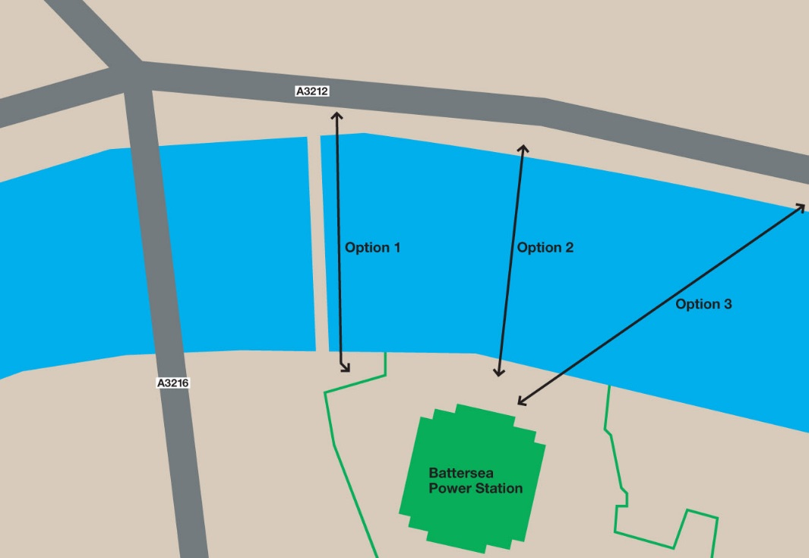
OPTION 1
This involves building a footbridge onto the east side of the railway bridge and would span roughly 170 metres
Pros
- This would be the simplest option as it would require the least amount of materials, therefore a lower cost. This is because the main structural support is already there, eliminating the need for piers etc.
- It would also avoid the need for large foundations as the existing foundations for the railway bridge could be extended for the footbridge.
- This would resolve the issue of having a small pavement on the north side as that in itself would be sufficient.
Cons
- This option would involve closing the railway bridge, so that construction work on it could take place. This would cause severe disruptions to public transport, as this bridge is the key bridge to crossing the river via the over ground to reach central London.
- This therefore would cause commuters huge time delays, making this option less viable.

- Furthermore adding weight to the bridge and only on one side could cause issues, such as the lateral excitation caused on the millennium bridge. However this is unlikely as the railway bridge is not a suspension or cable stayed bridge.
- Having said that the increased mass applied to the existing bridge could cause it to deteriorate at an accelerated rate, meaning both a new footbridge and a new railway bridge would have to be constructed.

OPTION 2
This involves building a footbridge straight across the river, with preferably only one pier close to the north side. This bridge would span roughly 160 metres.
Pros
- This option is the shortest, so would require less material for the actual pathway but would require piers or suspensions of some sort.
- This option could be built very elegantly, as it does not need to be attached to the railway bridge. This option therefore has better aesthetic capabilities.
- If built in a certain way, will give users crossing it a good view of London, prompting positive feedback and thus more chance for planning permission if another project in the same area arises.
- The access point on the north side is equidistant to all three major train stations surrounding it, making it useful for commuters from Battersea Power Station.

Cons
- This option would involve constructing new abutments, which would be expensive, time consuming and complicated due to underground pipes and tunnels.
- This choice would probably also require piers to support it, unless it was designed it such a way that it supported itself through curved bridge suspenders. However its life would be short as due to dead, live and dynamic loads being too great for that sort of design, it would probably break relatively quickly.
- The usage of piers would create obstruction in the river, which at low tide would be a hazard.

OPTION 3
Option 3 is the longest of all three, travelling diagonally across the river, spanning roughly 200-250 metres depending on the angle to which it is constructed.
Pros
- This option could be built very elegantly, as it does not need to be attached to the railway bridge. This option therefore has better aesthetic capabilities.
- Building this option, if built in a certain way, will give users crossing it a good view of London
- The access point on the north side is equidistant to all three major train stations surrounding it, making it useful for commuters from Battersea Power Station.
Cons
- This option is the longest and therefore would incur the most cost.
- In theory if all bridges kept at the same height and constructed of the same materials then the further the span, the more piers needed to support it. This would mean more constriction of navigation in the river, possibly creating hazards.
- As it is the longest it would also need larger abutments to support it, meaning more money and time is needed to begin the project.

An issue with all these option(less for option 1) is that bridges need large abutments. But due to the sub surface geology of the river Thames being mainly composited of clay and peat, a strong enough foundation cannot simply be founded by bedrock lying beneath the surface because there is very little. This is shown below:
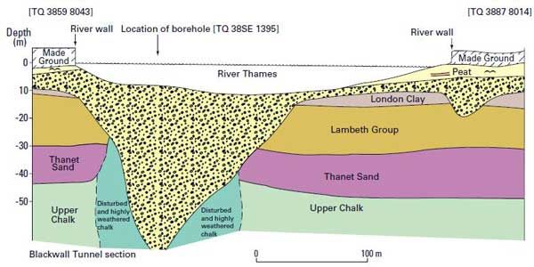
Therefore to support the bridge, solid concrete abutments need to be built. This involves both time and expense, which is a problem. Option 3 would suffer the worst from this as it is the longest, it should have the greatest dead load, meaning its abutments have to be larger. But as mentioned earlier, the abutments cannot be large due to the small pavement which is compulsory and the need to save as much intertidal shore as possible.
In terms of where the north side access is, even though option 1 and 3 are both equidistant to Victoria, Sloane square and Pimlico, annual entry and exit data shows that Victoria is the most important station with 8.79 million people, Sloane Square is second with 14.94 million and Pimlico is last with 8.79 million. Therefore it would be wiser to choose an alignment closer to Victoria and Sloane Square

Hence Option 2 is the most logical as it can have moderate abutments due to small span, keep the railway bridge open and is close to Victoria and Sloane Square.

