Desk Study
The new footbridge is needed due to the rennovation of the Battersea Power Station into a residential and commercial area, therefore due to poor public transport access on the south side of the river, a bridge is needed to get said residents to the north side of the river to access attions such as Victoria, Sloane Square and Pimlico. A bridge to support vehicles will not be necessary as the three surrounding stations are all within walking distance, hence the bridge will only have to support pedestrians and cyclists. A pedestrian only bridge will be useful as currently the only method of crossing the river is to cross the road bridge, which for both pedestrians and cyclists is hazardous. This benefit will be further utilised when the 3400 homes and various commercial stores at Battersea Power Staion have been built, giving shoppers and commuters easy access to nearby public transport.
The river walls on either side of the river are currently standing at 5.41 meters high. However due to climate change they need to be raised to a new height of 6.41 meters above sea level. Therefore the new bridge wil have to wait until construction of the river wall has finished. Having said that this is a relatively simple modular procedure which should not delay construction.
There are multiple obsatcles that need to be overcome to built the footbridge. The first is the redevelopment of the power station. It will most probably prevent materials being shipped in from the south side, therefore the base for construction will have to begin on the north side of the river. The redevelopment of the staion will take at least 10 years, so all construction of the footbridge will originate from the north side. The second key problem is that the main pier cannot be disturbed, so the south side base of the bridge needs to be built either to the left or the right of the pier.
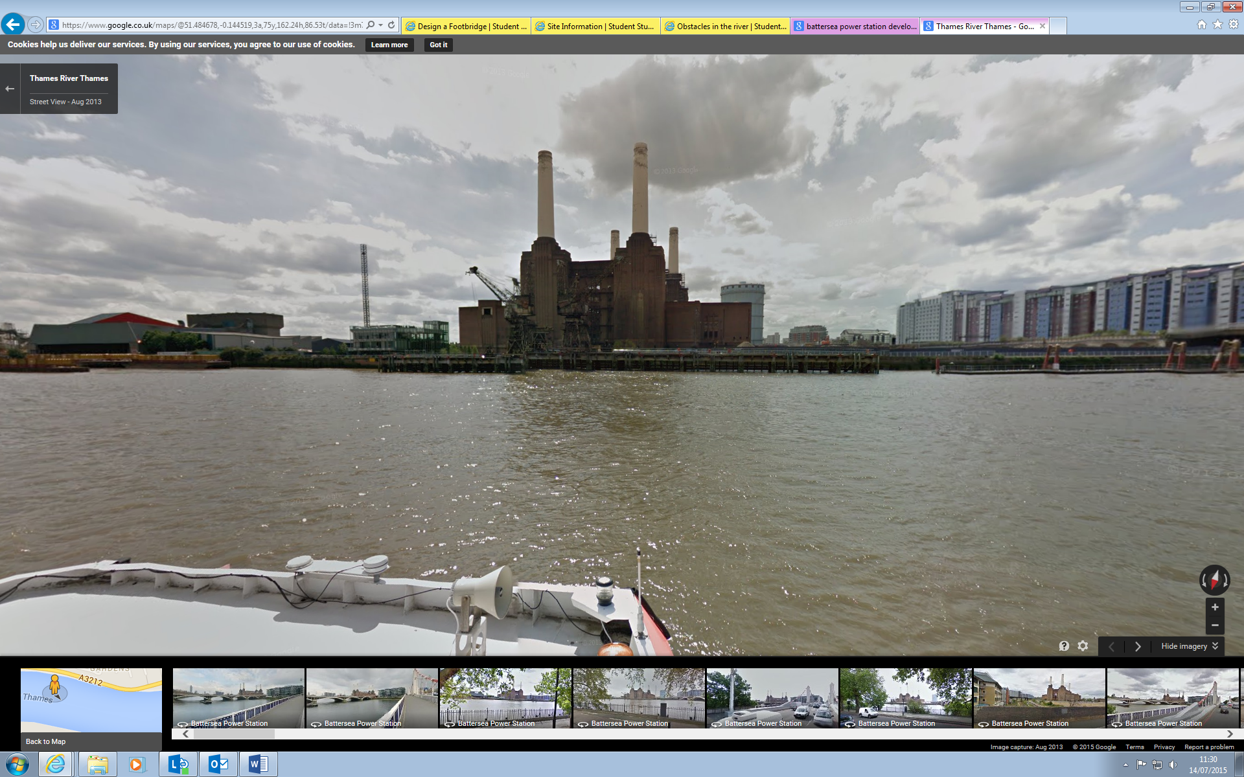
The large blue arrow indicates the location of the main pier, which is inline with the power staion. the black and white arrows represent possible locations for the southern base of the birdge to be built.

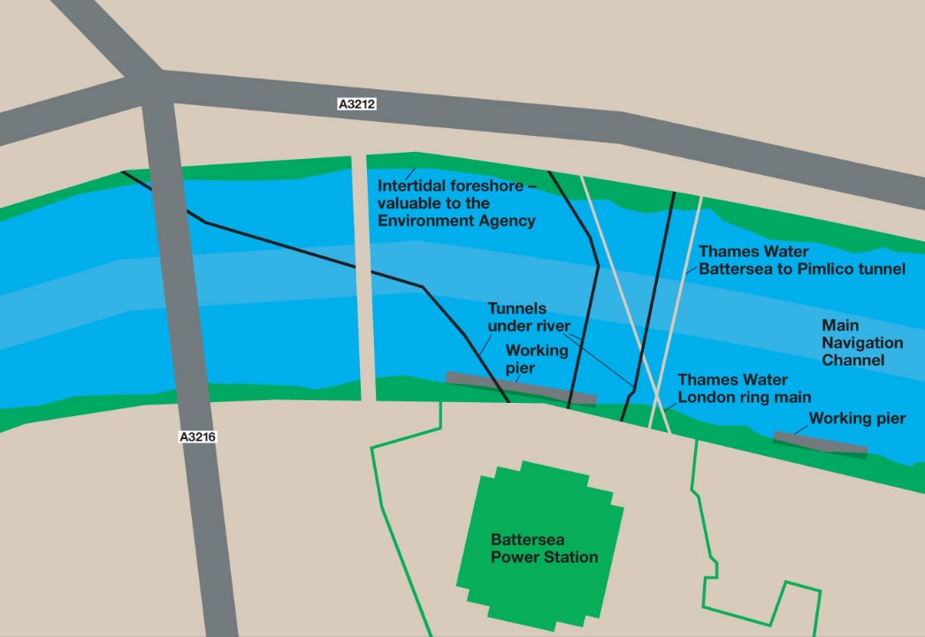
The third key issue is that the bases for the bridge need to be built deep into the ground. Therfore if there are underlying pipes in the ground then building strong foundations for the bridge will be difficult.
To the left is an image of all major underlying pipes and tunnels, which cannot be disrupted. As is visible the majority of the pipes and tunnels are concentrated on the right hand side of the main pier. Therefore it would be easier in theory to build a southern foundation on the left of the main pier, where the white arrow was in the last image.

Another issue is retaining the intertidal foreshore, as this is an important criteria of the Environmental Agency. The rail bridge to the left of the power station has done a good job of this when it was built in 1837. Below is an image of this. As is visible nearly half of the intertidal foreshore has been preserved. The construction of a footbridge would take up even less space as it needs to be able to carry less weight, therefore the foundation can be smaller.

The final issue is to not block the navigation of boats in the river. This means not dropping below 9.91 meters of clearance for all but one place. It also means not placing a bridge pier in the middle of the river as this is the main navigation channel. The diagram below illustrates this.
As is visible in the diagram the middle and right section cannot have a clearance below 9.91 meters. But the north side can have a clearance below 9.91 subject to a risk assessment.
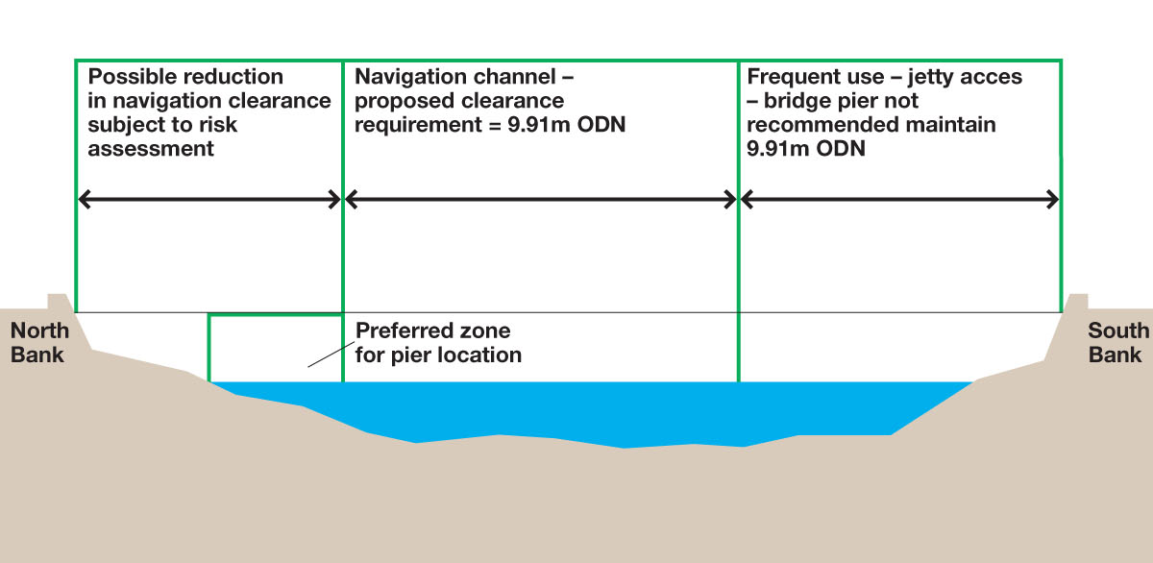

This is useful as one key issue with constructing to the left of the main pier is that the pavement is very thin on the north side so access would be limited.
RISK ASSESMENT
Risks involved in building below clearance of 9.91meters on north side:
- Reduce clearance by around 3-4 meters, which could lead to more boats trying to pass through the centre span of the bridge, which would increase water traffic possibly leading to more boat collisions.
- Centring the main navigation channel through the footbridge, would cause the navigation channel through the railway bridge to the west to become more constricted, and considering that said railway bridge has three piers, this creates hazards of boats colliding.

Relating the bridge to nearby structures will be difficult as many of the surrounding buildings and bridges all date back to the 1800's. Therefore to build a futuristic looking bridge such as the Gateshead Millennium Bridge would be denied planning permission as it doesn't fit in with the surrounding landscape. Therefore it is important that when designing the footpath, it be modelled in such a way that is compliments both the power station and the old bridges next to it.

