Key types of bridges
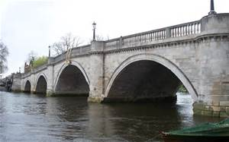
Arch bridges – These bridges uses arch as a main structural component (arch is always located below the bridge, never above it). They are made with one or more hinges

Beam bridges – Very basic type of bridges that are supported by several beams of various shapes and sizes.

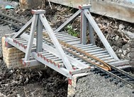
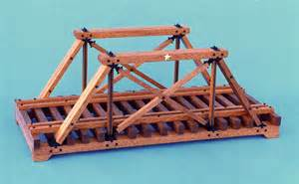
Truss bridges – A bridge design that uses diagonal mesh of posts above the bridge. The two most common designs are the king posts and queen posts King Post Queen post

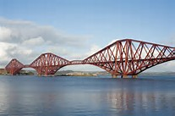
Cantilever bridges – Similar to arch bridges, but they support their load not through vertical bracing but through diagonal bracing. Often use truss formation below and above the bridge. They also use counterwegihts to help support the middle section of the bridge.

Suspension bridges – Bridges that use ropes or cables from the vertical suspender to hold the weight of bridge. Traditionally only use two suspenders but depends on the span of the bridge.

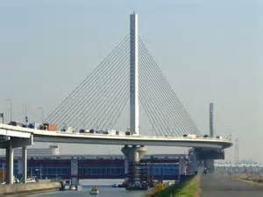
Cable-stayed bridges – Bridge that uses cables that are connected to one or more vertical columns. Cables are usually connected to columns in two different ways; harp design (each cable is attached to the different point of the column) and fan design (all cables connect to one point at the top of the column).

