LOGISTICS
The redevelopment of the Battersea Power Station poses some issues as it means that accessing the south site with materials to begin construction could be tricky.
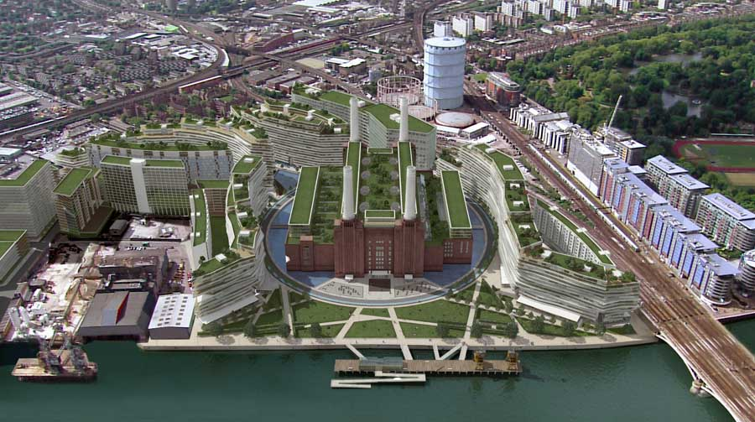
This is the planned redevelopment that is already underway. Clearly these building will make accessing the site difficult.
However a route through the buildings is still possible as shown by the red line.

But due to the narrow roads it will be difficult to preassemble the pieces and then carry them in, meaning that the majority of the construction and assembling will have to be carried out on the site.
As is seen in the image in the blue oval, there is still lots of space for a large abutment and enough space for a large and fairly high pylon.

