London Millennium Bridge
London's Millennium Bridge is the first pedestrian river crossing over the Thames in central London for more than a century.
It is a 325m steel bridge linking the City of London at St. Paul's Cathedral with the Tate Modern Gallery at Bankside.
The 4m wide aluminium deck is flanked by stainless steel balustrades and is supported by cables to each side. These cables dip below the deck midway across enabling unimpeded views of London.
The bridge is a very shallow suspension bridge where the highly tensioned cables sag 2.3m over the 144m of the central span, a span to dip ratio of 63:1. This is around 6 times shallower than a conventional suspension bridge.
The key engineers of the bridge were Ove Arup and Partners.
The largest span is the centre span - 144 m between the north and south piers. Four 120 mm diameter locked coil steel cables are used on each side of the bridge. In total, they maintain around 2300 tonnes of force. Twin 20 m deep 6. m diameter bases into the river bed support each pier. These were constructed as shafts which were then backfilled with reinforced concrete and topped with a 3 m deep pile cap.
The arms on the bridge link the bridge deck to the cables every 8 m. They are steel hollow boxes ranging from 450 mm square to 225 mm square at the cables. Movement joints are installed every 16 m on the bridge deck. These allow the deck to expand and contract as the cables move.
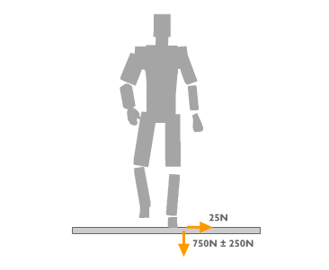
The London Millennium Bridge was opened in June 2000, but on the first day, users noticed that the bridge was swaying from side to side a great deal, causing the crossing to be too difficult. Thus the same day that it opened it was shut. Research began on why it swayed so much, and international experts were called in to help solve the problem. They concluded that the sway was caused by the forces that people exert whilst walking.
The diagram to the left should help to explain why the bridge swayed. When we walk we create a pattern of forces as our mass rises and falls. This creates a vertical fluctuating force of around 250 N which repeats with each step.
There is also a small sideways force caused by the sway of our mass as our legs are slightly apart. This force, of around 25 N. with up to 2000 people crossing at one time on the first day of opening, it is imaginable that 50,000 N of force is going to cause movement.
The image underneath is one of the designs constructors used to reduce the forces of synchronous lateral excitation caused by the sideways forces of walking.

