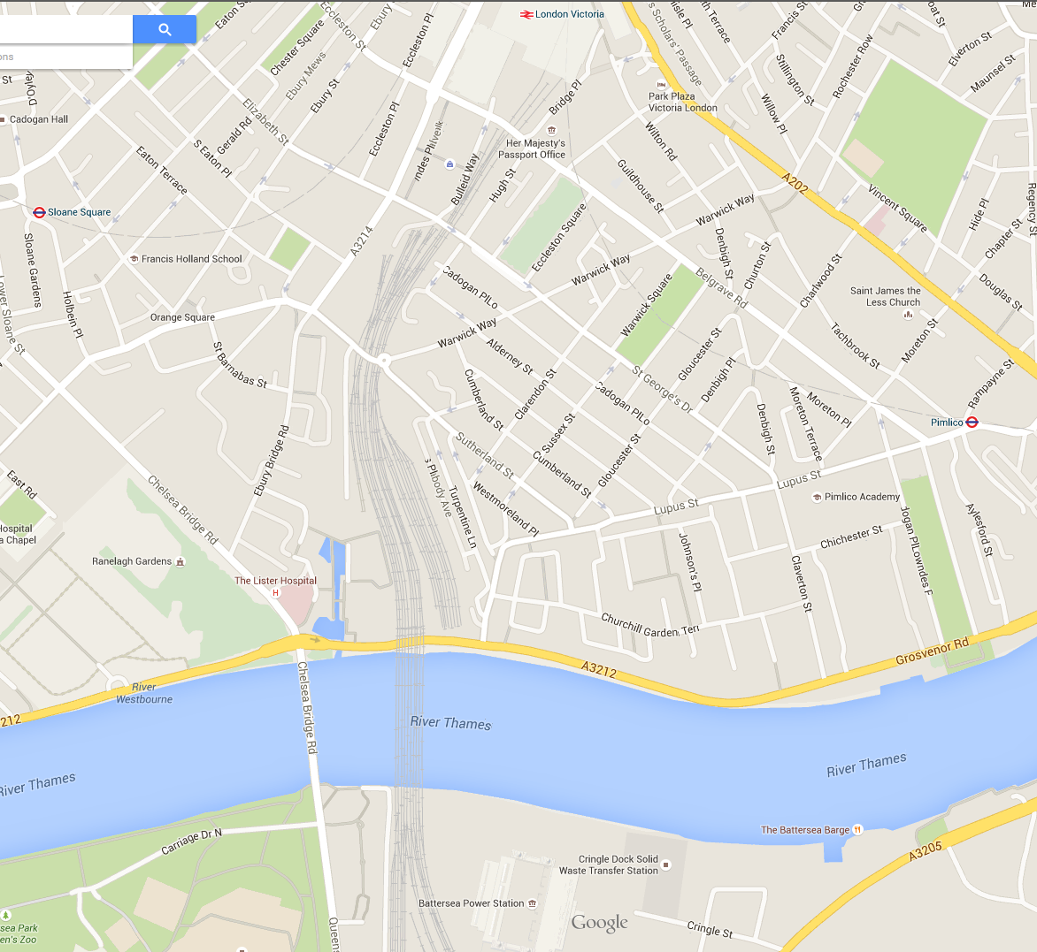
CV
Average pedestrian speed = 4ft/second
CV
Distance from to: Sloane Square- 4224- 17.6 minutes
Pimlico- 3168 – 13.2 minutes
Victoria – 6336 – 26.4 minutes
Total minutes to each = 57.2 minutes

Distance from to: Sloane Square- 5280 – 22 minutes
Pimlico- 3420 – 14.25 minutes
Victoria- 5808 – 24.2 minutes
Total minutes to each = 60.45 minutes

Distance from to: Sloane Square- 6864 – 28.6 minutes
Pimlico- 2112 - 8.8 minutes
Victoria- 4752 – 19.8 minutes Total minutes to each = 57.2

