ROUGH CALCULATIONS

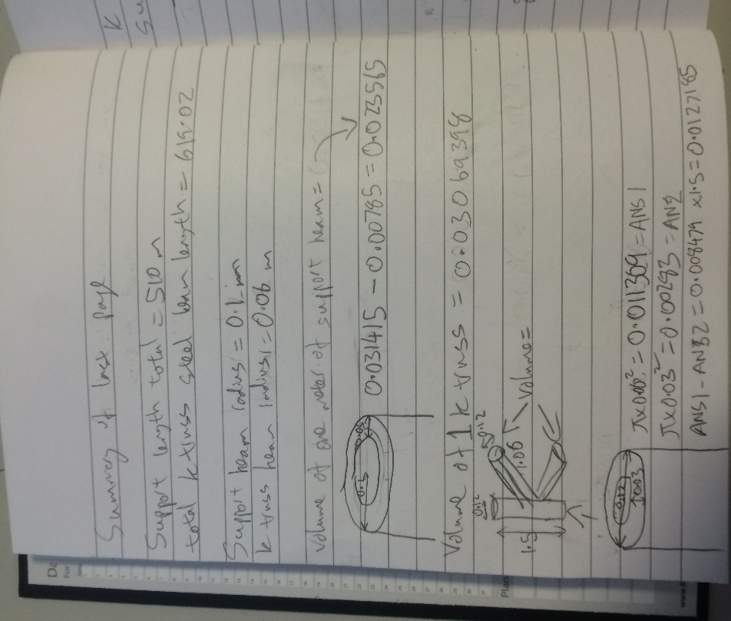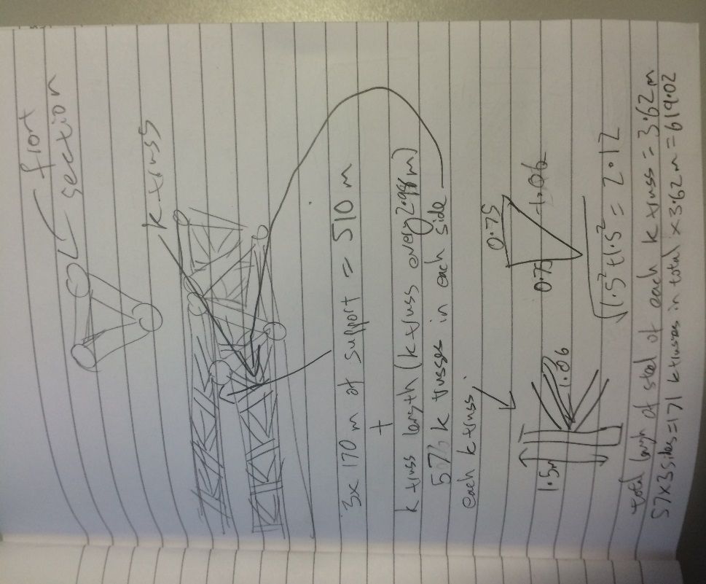Taking inspiration from the Sundial Bridge in California, the walkway will be constructed from non-skid glass panels in steel framework with granite accents. The steel framework will be designed with trusses and support the glass walkway layered over it.

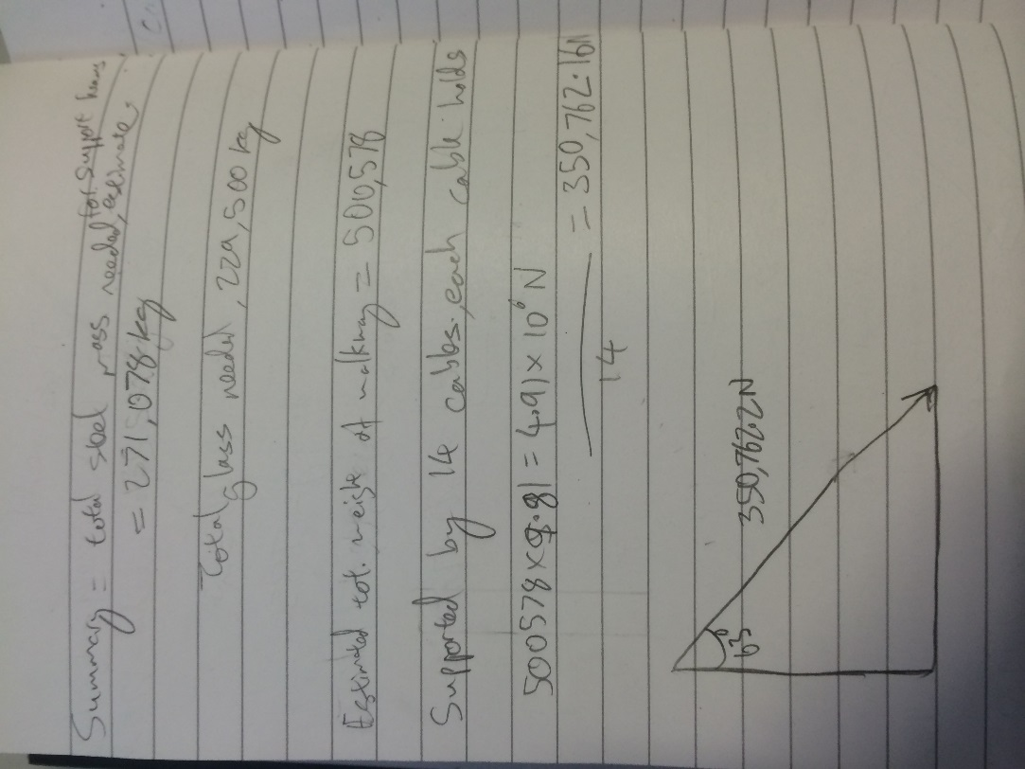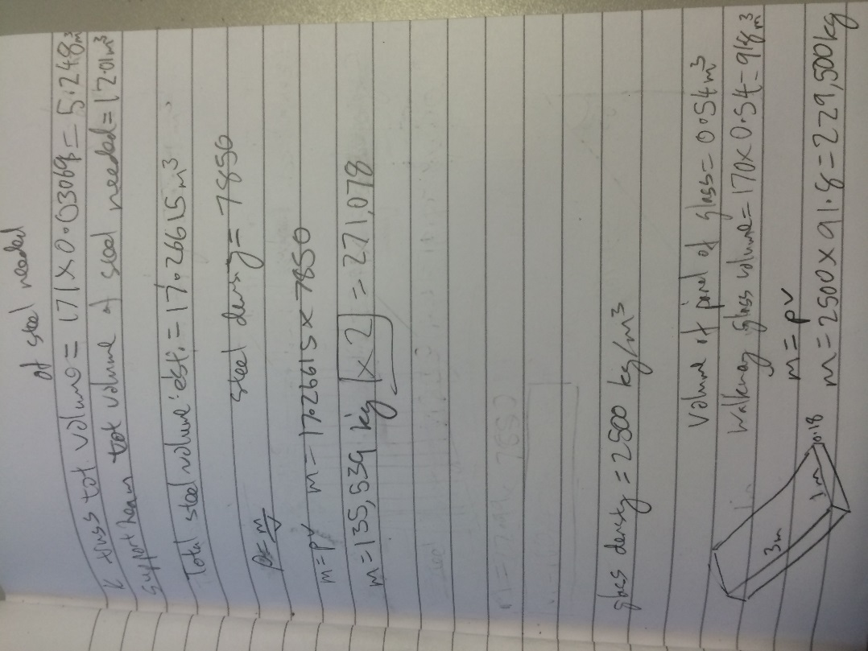

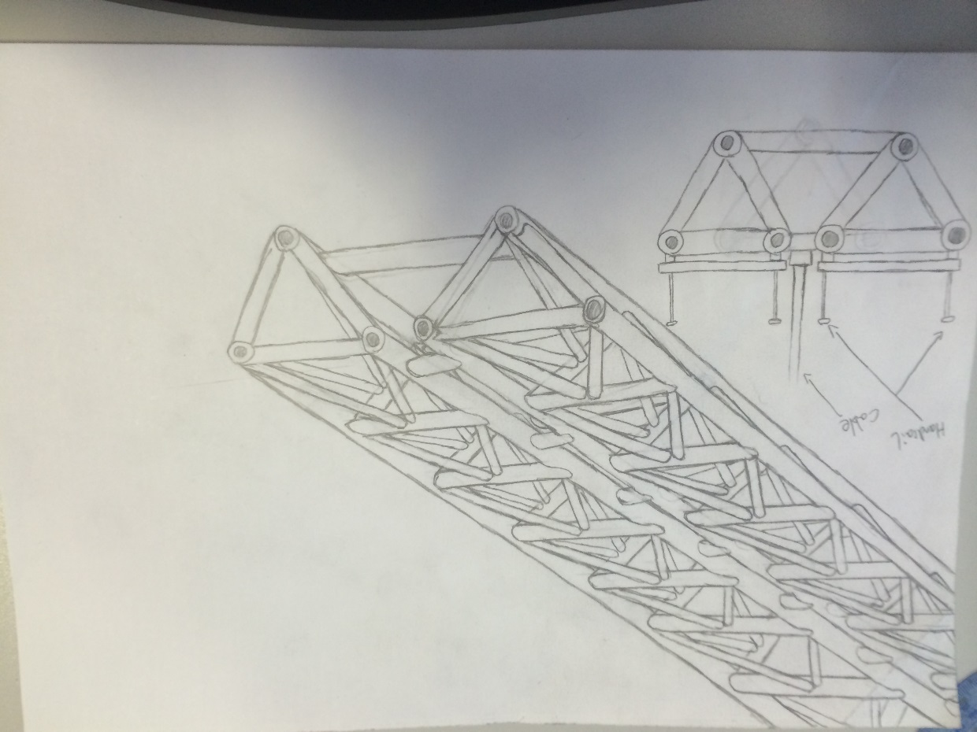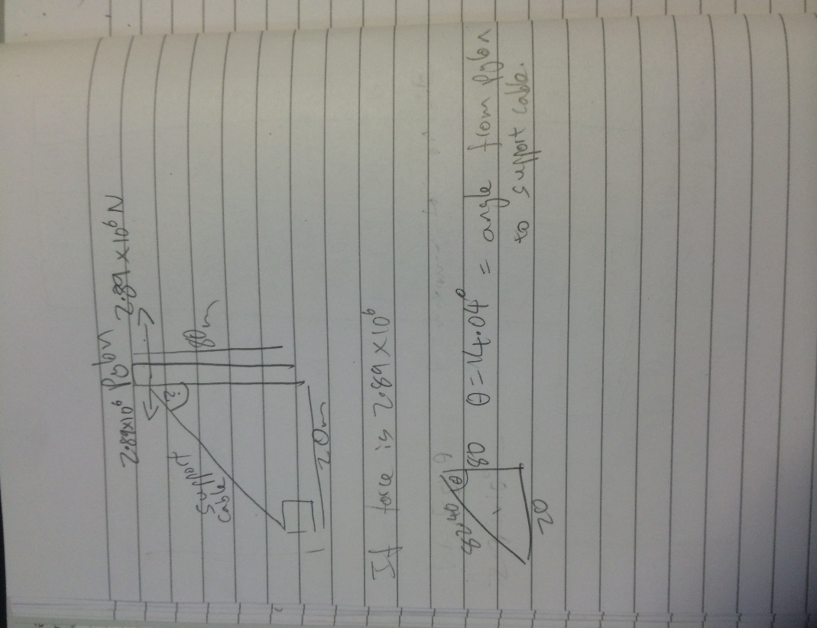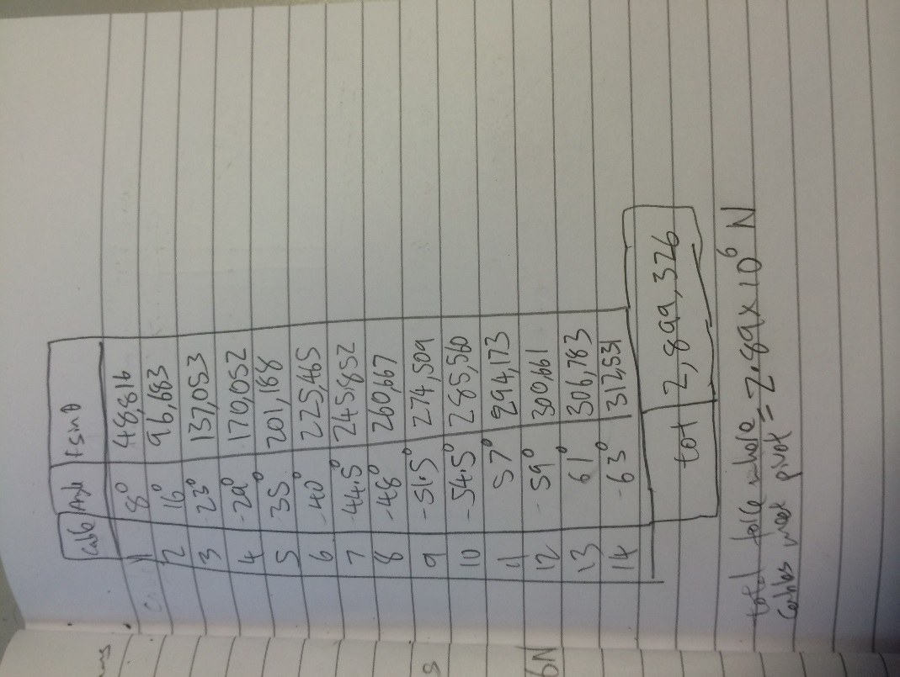

The sketch to the left shows the design for the walkway. It features 6 main support beams, which are held together with K trusses.

The sketch below it shows a cross sectional sketch of the walkway, and how the glass sheets are mounted onto the support beams. it also shows where the cable supports the walkway.

This diagram shows a possible intermediate mounting between the support beams and the glass walkway.