Today, I would like to introduce you the activity I have created on Make A Scape in these four days. First of all, let me show you where I have got this inspiration from:
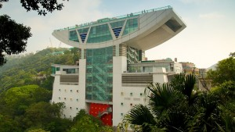
This is a picture of the Peak Tower in Hong Kong. It was the first Terry Farrell & Partners project in China. It is a seven-storey tower, and is a famous tourist attraction in Hong Kong. Due to the fact that it is located near the summit of Victoria Peak which is the tallest mountain in Hong Kong, you can see the beautiful Hong Kong skyline and the Harbour as you stand on the distinctive bowl-shaped platform of the tower. This always keeps me being fascinated. The tower echoes the curving eaves typical of traditional Chinese architecture. It contradicts to many other buildings in Hong Kong which are all straight and tall. They are all skyscrapers. The tower has a pleasing appearance but is very practical at the same time, in the bowl-shaped platform; there are hotels, escalators, lifts, restaurants, viewing platforms etc a tram is also provided for tourist to go up. I concentrated on this because the bowl shape part looks quite heavy, the way it acts against force of gravity make me want to see whether this works in Make A Scape as well.
So, based on the research that I have done, I created this activity called the “platform” activity. The aim of this activity is to give KS3/4 students a brief idea of where the centre of gravity of an object is and understand that the width of the base of the object and the height of its centre of mass affect its stability. It is just a relaxing game so can be carried anywhere and anytime.
Instructions:
In this game, you are trying to build the widest and tallest platform you can without it failing the strength test. You start off with two supports at the bottom, being at most 4 units apart.
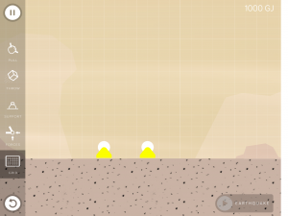like this
Then, you build the structure upwards and outwards, the minimum height of your structure has to be 4 units, and you will try to make your structure as wide as possible. After you have made your platform, test it in the strength test and see whether it is stable enough to be in the reality. Write down how tall, how far your platform gets to and how long does it survive in the strength test!
Here is an example of what I have done:
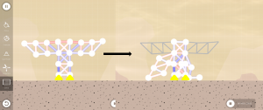
The supports are 2 units apart from each other. The height of my structure is 6 units and the platform reached to be 14 units wide. It survived in the wind load test, having 0 breakages. But for the earthquake test, it only stayed up for 1 second. I believe you can all do better than me…. You can always compete with your friends in this activity, seeing which one of you can make wider & taller platform with a longer survival time in the strength test.

Hopefully by the end of this activity, students may be able to find out that objects with a wide base, and a low centre of mass, are more stable than those with a narrow based and a high centre of mass.

